

**Product Dissection for Facebook**

### **Company Overview:**

Facebook, the brainchild of Mark Zuckerberg, Eduardo Saverin, Dustin Moskovitz, and Chris Hughes, has revolutionized online communication and social interaction since its inception in 2004. Acquired by Meta Platforms, Inc., Facebook has established itself as a global social media giant, boasting over 2.91 billion monthly active users worldwide. The platform's captivating interface, innovative features, and emphasis on visual storytelling have captivated millions, solidifying its position as a leading force in the social networking landscape.

### **Product Dissection and Real-World Problems Solved by Facebook:**

Facebook, a global social media phenomenon, has tackled real-world challenges through its innovative product offerings. With a focus on connecting the world, Facebook empowers users to authentically share their experiences and passions, bridging the gap between digital interactions and genuine connections. By allowing users to share updates, photos, and videos accompanied by captions, locations, and tags, Facebook provides a solution to the need for meaningful expression and engagement. This core feature addresses the problem of connecting with others in an increasingly digital world, enabling users to form genuine relationships and engage in conversations that transcend geographical boundaries.

Facebook's innovative engagement features, such as likes, comments, and personalized content recommendations through the "Explore" feature, have revolutionized how users interact with content. By addressing the challenge of content overload, Facebook curates relevant content, helping users discover new accounts, posts, and trends tailored to their interests. Furthermore, Facebook's introduction of tagging has transformed content discovery by allowing users to link their posts with relevant topics and individuals. This innovative approach effectively addresses the challenge of navigating through a sea of content to find relevant information, making it easier for users to connect with content aligned with their interests and engage in conversations that matter to them.

In conclusion, Facebook's product design has successfully tackled real-world problems by creating a platform that fosters connections, nurtures creativity, and offers a space for self-expression. Through its diverse features, Facebook addresses the need for authentic engagement, content curation, and meaningful discovery, shaping the digital landscape and providing practical solutions to the evolving needs of its global user base.

### **Case Study: Real-World Problems and Facebook's Innovative Solutions**

Facebook, a global social media giant, has revolutionized the way we connect, communicate, and engage with the world around us. Its innovative product features have effectively addressed a multitude of real-world challenges, empowering individuals to stay connected with loved ones, engage with diverse perspectives, and discover new opportunities.

**Problem 1: Bridging the Distance: Fostering Connections in a Digital World**

Real-World Challenge: As our lives become increasingly digital, the need for genuine connections and a sense of belonging remains paramount. However, geographical distances and social barriers can hinder the formation of meaningful relationships.

**Facebook's Solution:**

Facebook tackles the fundamental human need for connection by providing a platform to bridge geographical gaps and foster genuine relationships. By enabling users to create personalized profiles, share updates, and engage with friends, family, and groups, Facebook creates virtual communities that transcend physical boundaries. This feature addresses the challenge of social isolation and loneliness, particularly for those living far from loved ones or facing social barriers.

**Problem 2: Navigating Information Overload: Finding Relevant Content**

Real-World Challenge: The vast amount of information available online, while empowering, can also lead to information overload. Users often struggle to filter through irrelevant content to find information that matters to them.

**Facebook's Solution:**

Facebook addresses the issue of content overload through its intelligent content curation algorithms. By analyzing user preferences and interests, Facebook's "News Feed" delivers a personalized stream of relevant content, ensuring that users are exposed to information that matters to them. This feature tackles the problem of sifting through vast amounts of irrelevant content, enabling users to focus on what is truly important to them.

**Problem 3: Empowering Self-Expression: Sharing Stories and Building Identity**

Real-World Challenge: In a world where individuals seek to connect with others on a deeper level, there is a growing need for platforms that empower self-expression and identity construction.

**Facebook's Solution:**

Facebook empowers individuals to express themselves authentically and share their unique stories with the world. The platform's ability to accommodate text, photos, videos, and live streams provides users with diverse tools for creative expression. This feature addresses the need for self-expression and identity construction, particularly in a world where individuals seek to connect with others on a deeper level.

**Problem 4: Fostering Belonging: Building Communities and Shared Interests**

Real-World Challenge: Many individuals seek a sense of belonging and shared interests, particularly those with niche interests or those living in remote areas. Traditional social circles may not provide the opportunity to connect with like-minded individuals.

**Facebook's Solution:**

Facebook goes beyond individual connections to foster a sense of belonging and shared interests. By enabling users to join groups based on their hobbies, passions, and beliefs, Facebook creates virtual communities that provide a sense of belonging and shared purpose. This feature tackles the challenge of social isolation and lack of community engagement, particularly for individuals with niche interests or those living in remote areas.

**Real-World Impact: A Catalyst for Social Change**

Facebook's impact extends beyond its digital realm, influencing real-world social change. The platform has been instrumental in mobilizing support for social movements, organizing political campaigns, and raising awareness about critical issues. By providing a platform for collective action and advocacy, Facebook has empowered individuals to make a positive impact on their communities.

**Conclusion: A Platform that Connects, Empowers, and Drives Change**

Facebook's innovative product features have effectively addressed a multitude of real-world problems, transforming the way we connect, engage with information, and express ourselves. By fostering authentic connections, curating meaningful content, empowering self-expression, and building communities, Facebook has become an indispensable tool for communication, self-discovery, and positive social change.

### **Top Features of Facebook:**

1. **Personalized Profiles:** Facebook allows users to create personalized profiles, showcasing their interests, personal information, and photos. This feature enables users to establish a unique online identity and connect with others based on shared interests.
2. **Dynamic News Feed:** The News Feed provides a personalized stream of updates, posts, and content from friends, groups, and Pages that users follow. This feature keeps users connected with the people and topics they care about, fostering a sense of community and engagement.
3. **Posts and Sharing:** Users can share text, photos, videos, and links, sparking conversations, fostering personal connections, and expressing creativity. This feature enables users to share their experiences, thoughts, and passions with a global audience.
4. **Likes and Comments:** Users can express reactions and opinions on posts through likes and comments. This feature creates interactive discussions, engages users with their network, and promotes meaningful interactions.
5. **Groups and Communities:** Users can join groups based on shared interests, enabling them to connect with like-minded individuals, engage in niche discussions, and discover new perspectives. This feature fosters a sense of belonging, provides access to diverse viewpoints, and supports community building.
6. **Events and Gatherings:** Users can create and attend events to organize gatherings, activities, and celebrations, both online and offline. This feature facilitates social connections, promotes shared experiences, and enhances community engagement.
7. **Messaging and Private Communication:** The private messaging feature enables one-on-one or group conversations. This feature facilitates direct communication, personal connections, and building strong relationships.
8. **Targeted Advertising:** Facebook's advertising tools allow businesses to reach a wide audience, promoting their products, services, and brand presence. This feature generates revenue for the platform and connects businesses with their target audience.
9. **Marketplace and Commerce:** The Marketplace is a platform for buying and selling goods and services, facilitating commerce, local connections, and economic opportunities. This feature enables users to find products, discover local businesses, and support entrepreneurship.
10. **Gaming and Entertainment:** The platform offers a variety of games and entertainment options, providing users with opportunities to play, compete, and engage with others in a fun and interactive environment. This feature expands the platform's appeal and provides a space for leisure and enjoyment.
11. **Watch and Video Content:** The Watch feature provides a platform for watching videos, including live streams and original content. This feature caters to diverse interests, offers entertainment options, and expands the platform's content offerings.
12. **Fundraisers and Social Impact:** Facebook allows users to create and support fundraisers for charitable causes, enabling social impact, community support, and making a positive difference. This feature highlights the platform's commitment to social responsibility and empowers users to contribute to causes they care about.

### **Schema Description:**

The schema for Facebook involves multiple entities that represent different aspects of the platform. These entities include Users, Posts, Comments, Likes, Followers, Hashtags, and more. Each entity has specific attributes that describe its properties and relationships with other entities.

**User Entity:**

Users are at the core of Facebook. The user entity contains information about each user:

* **UserID (Primary Key)**: A unique identifier for each user.
* **Email**: The user's email address for account-related communication.
* **Full_Name**: The user's full name as displayed on their profile.
* **BirthDate**: The user's when he born.
* **Registration_Date**: The date when the user joined Facebook.

**Post Entity:**

Posts capture the visual content shared on the platform:

* **PostID (Primary Key):** A unique identifier for each post.
* **UserID (Foreign Key referencing User Entity**): The user who created the post.
* **Context**: Text accompanying the post, providing context..
* **PostedAt**: The date and time when the post was created.

**Comment Entity:**

Comments enable users to engage in conversations around posts:

* **CommentID (Primary Key)**: A unique identifier for each comment.
* **PostID (Foreign Key referencing Post Entity):** The post being commented on.
* **UserID (Foreign Key referencing User Entity)**: The user who posted the comment.
* **CommentText**: The text of the comment.
* **CommentedAt**: The date and Time when the comment was posted.

**Like Entity:**

Likes represent user appreciation for posts:

* **LikeID (Primary Key):** A unique identifier for each like.
* **PostID (Foreign Key referencing Post Entity):** The post being liked.
* **CommentID:** The Users who is comment in the post.
* **UserID (Foreign Key referencing User Entity):** The user who liked the post.
* **LikedAt:** The date and Time when the like was registered.

**Friendships Entity:**

The Users who is our friends:

* **FriendshipID:** The friend ID.
* **UserID1 :** The users who is connect with us.
* **UserID1 :** The users who is connect with us.
* **EstablishedAt:** When they are connected with us.

**Relationships are:**

* **Users post Posts –** Each user can post multiple posts.
* **Users comment on Posts –** Users can comment on multiple posts, and each post can have multiple comments.
* **Users like Posts –** Users can like multiple posts, and each post can have multiple likes.
* **Users follow other Users –** Users can follow multiple users and be followed by multiple users.

**ER Diagram:**

Let's construct an ER diagram that vividly portrays the relationships and attributes of the entities within the Facebook schema. This ER diagram will serve as a visual representation, shedding light on the pivotal components of Facebook's data model. By employing this diagram, you'll gain a clearer grasp of the intricate interactions and connections that define the platform's dynamics.

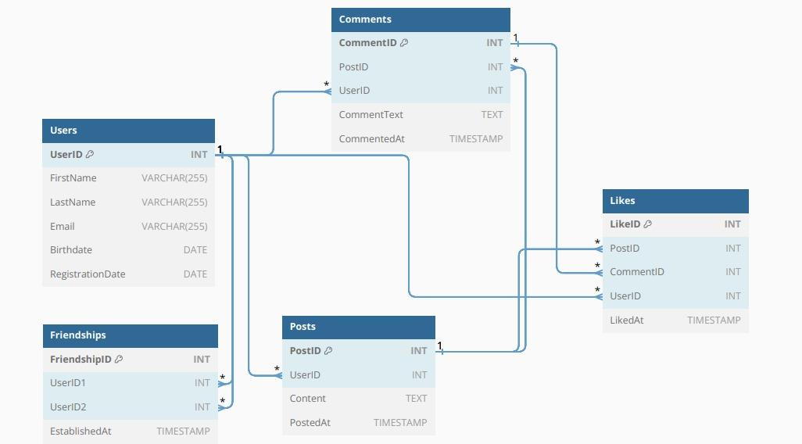

**Conclusion:**

Facebook is a social media platform with a complex schema that enables users to connect with each other, share content, and build communities. Its Entity-Relationship diagram (ERD) provides a visual representation of the relationships between the different entities in the Facebook schema, such as users, posts, comments, likes, groups, and pages.

This project has explored the design of Facebook's schema and ERD, providing insights into how the platform effectively manages the complexities of user interactions and content sharing. The schema's use of normalization and relationships between entities allows Facebook to efficiently store and retrieve data, while also providing users with a personalized experience.

Facebook's success can be attributed in part to its effective schema design. The platform's ability to manage large amounts of data and provide users with a personalized experience is essential to its popularity. By understanding Facebook's schema, developers can gain valuable insights into how to design and build social media platforms that are both scalable and user-friendly.